Task 5

Legal Portfolio for the Potential Investor
The following information details various aspects that ensure that the legal personnel in-charge meets required expectations for the proposed business venture.
Qualification and Specialization
Area: Bachelor of Laws (Cum Laud)
Specialization: Commercial, Law of Business Organization
Number of Legal Experts
The firm boosts of enough and qualified manpower to handle all commercial and business organization, and related issues
4 senior attorneys with over 25 years of experience in the subject area
40 years of combined knowledge in the field
Previous Work
The firm has been engaging in the following areas over time since its formation
- Business Formation and Registration
The firm has participated in the formation of various business organizations, namely: partnerships, corporations and companies.
Preparation of business formation agreements, articles of associations and memorandum of understanding between individuals and individuals, individuals and organizations, and between organizations and organizations,
Spearheading registration of various business formations
- Business Restructuring
Active participation in business restructuring of various nosiness organizations across the nation in view of the investor’s needs or select companies restructuring plan.
Preparation of business restructuring plans and guidelines for select organizations and for the sector to provide a proper and sound restructuring plan and bring certainty in the industry
- Dispute Resolution
Involved in dispute resolution processes on request from various organization across the industry with a view of reaching an amicable solution by the worrying parties
Creation of a Dispute Resolution Manual and Guideline to guide sector players - the manual includes a dispute resolution mechanism process that fosters cooperation between parties concerned.
Issues Likely to Arise
- Business Formations and Funding
Upon deliberation and advice to the potential investor, appropriate business form will be proposed and on acceptance, case its formation.
Articles of association will be drafted and approved by all persons involved, save for a sole ownership.
Registration will be lodged and finalized within the statutory time.
A proposal for a viable investment methodology for various funding will be proposed (Fig 1)
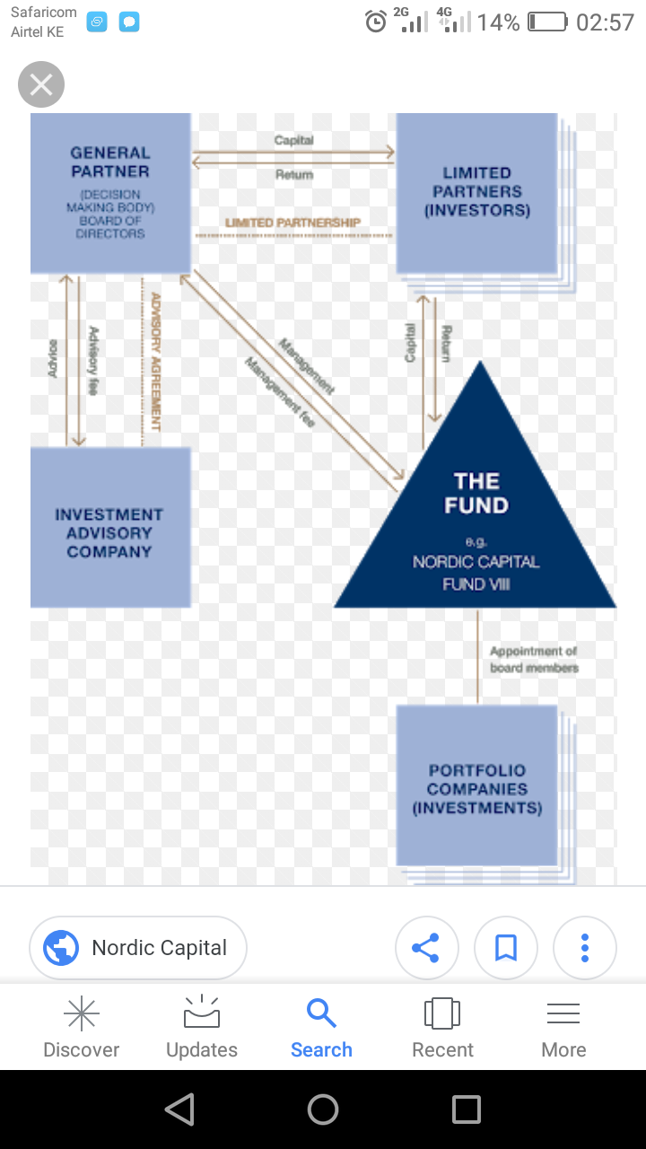
Fig 1: Proposed Investment methodology
- Compliances
Compliance of all statutory regulations will be adhered to and followed to completion.
Areas of compliance will include:
Statutory number of investor for a select form of business
- Capacity of persons involved
- Shareholding Requirements
- Registration
- Registration Fees
- Tax Compliance, etc
- Business Dissolution
In the event the business needs to be dissolved, we will ensure that it is per the articles of association
Will give proper and effective business dissolution steps that are cost effective and satisfies all affected persons

